Technology News from BIT
donateNYC Website and Smartphone Apps go Live!
Got something to donate? Searching for some “treasure” that would have gone out in someone’s trash? Want to help others and NYC by putting less into landfills? Now it’s easy with donateNYC, a new program developed as a cross-bureau collaboration between BRS and BIT that makes it easy for residents, agencies and businesses donate goods, and support local charities.
With donateNYC, anyone connected to the internet can easily give and find used items in NYC, from clothing to housewares, furniture, and much more, through a set of smartphone apps and a public website developed by BIT. It also includes information about the nonprofit social service organizations, thrift shops, and other local reuse organizations in New York City that accept and redistribute donated goods.
A special BIT team, headed by development manager Don Han under the leadership of BIT CIO Edmund Lee, took up the challenge of creating the smartphone apps. “It was the first time BIT has developed apps for the Android and iOS platforms,” explained Han. “Built internally, it required interfacing with Google and Apple and creating a robust infrastructure able to handle thousands of potential users. We are now using these capabilities to build an expanded DSNY app for the fall. It will provide the public targeted alerts for trash pickup, recycling, drop-off events, snow alerts, and much more.”
The BRS team, led by Deputy Director of Policy and Programs Kate Kitchener, and Senior Manager of Donations and Reuse Ben Rose, worked together with BIT to conceive of the new service, test the tools, and train the city’s non-profit reuse organizations on how to use the website and apps to reach new potential donators and expand their social services networks.
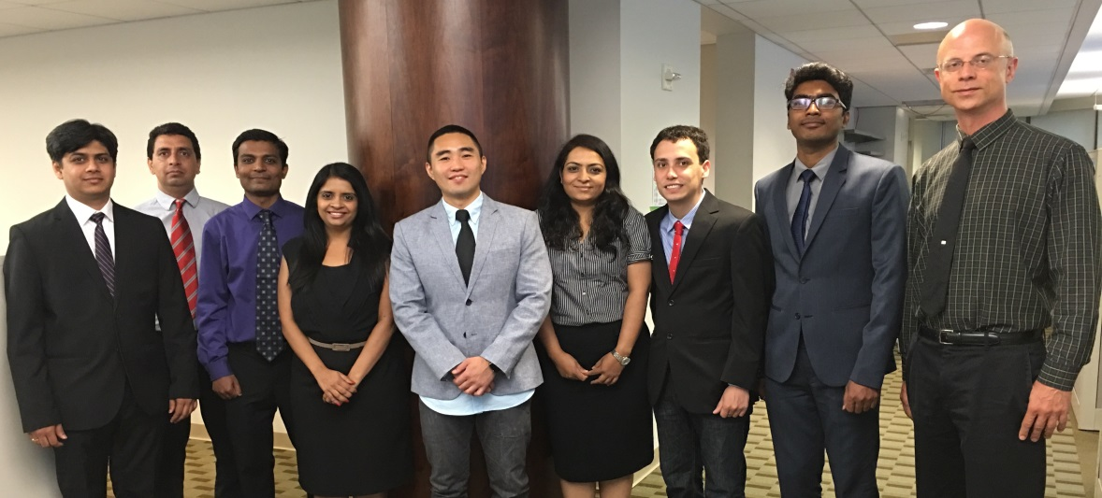
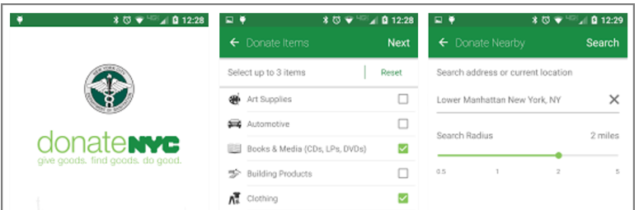
needed to expand our skill set and

BIT’s donateNYC app and development team (l to r): Kuldeep Shah, Jaspreet Singh, Dinesh Doshi, Maitri Brahmbhatt, Don Han, Janki Patel, Alex Place, Phanidhar Mothukuri, and Greg Nightingale. (Not pictured: Cici Jiang and Elana Shafir, BRS: Kate Kitchener and Ben Rose)
donateNYC is part of New York City’s initiative to send zero waste to landfills by the year 2030.
For more about donateNYC and awards for innovative reuse projects, click here, or go to nyc.gov/donate.
--------------------------------------------------------------------------------------------------------------------------------
DETAILED LINKED MATERIAL
With the donateNYC app, users can:
• Search by material type for vendors that will accept used goods or that sell specific types of second-hand items
• Use a current GPS location or an address to find a donation drop-off place or second-hand vendor nearby
• Get maps and learn drop-off hours and contact information
• Find out if vendors will pick up donated goods
By donating and reusing goods instead of discarding them, New Yorkers will be able to reduce waste, conserve energy and resources, and save money, while also helping provide jobs and services for others.

donateNYC combines several different reuse initiatives developed over the last decade by Sanitation and the Center for Materials Reuse (CMR) at City College, CUNY into one program.

CMR (funded by DSNY since 2005) also launched the Innovative Reuse Projects Program to coincide with the June 27th launch of donateNYC. CMR solicited proposals of up to $10,000 from non-profit partners that reuse material to support the arts, public health, and other causes to jump start new and innovative reuse projects. The inaugural year’s winners were:

Recycle-A-Bicycle will establish a summer youth employment program focused on bicycle reuse and repair.
Friends of Materials for the Arts will pilot an upcycling and design project that will work with immigrants, seniors, youth and under-employed populations to make reusable bags for sale using textile scraps— with all sales going directly to the program participants.
Lower East Side Ecology Center and Power My Learning (joint project) will create an “e-swap” program to exchange, reuse and repair unwanted computers for the purpose of establishing computer labs in schools.

